# **ENVIRONMENT MONITORING**

Phase 4 project submission documents

# TEAM MEMBERS

RITHTHIGA.A

SANKARI.V

BARANIKA.G

SUBASRI.K

TOPIC: this section continue building the performing different activities like feature

Engineering model Training mention et as per the instructions in the project

**INTRODUCTION** :

* Environmental monitoring is a tool to assess environmental conditions and trends, support policy development and its implementation, and develop information for reporting to national policymakers, international forums and the public.
* Monitoring water quality is an example of environmental monitoring since you are tracking and measuring the pollutants in the water.
* Monitoring involves paying close attention. It's a type of systematic observation, like the monitoring of criminals by the police. Kids who are up to something don't like their parents' monitoring their every move.
* monitoring design, quality assurance, data management, data analysis, research and development in support of data collection

**DATA SET:**

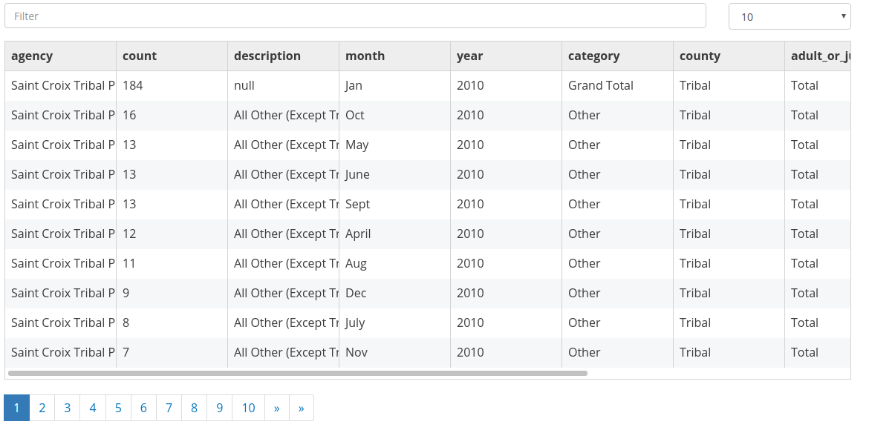

**OVERVIEW OF THE PROCESS:**

1. **PROBLEM DEFINITION**

* A problem statement is a clear and concise description of the problem or issue a team aims to address in a project

1. **Monitoring The Building Environment**

* Building automation is an example of a distributed control system - the computer networking of electronic devices designed to monitor and control the electronic

1. **MEASURING THE DATA**

* Measurement means the description of data in terms of numbers and this, in turn, means taking advantage of the many benefits that operations with numbers and mathematical thinking provide

1. **CATALOGING THE DATA**

* an organized inventory of data assets in the organization. It uses metadata to help organizations manage their data. It also helps data professionals collect, organize, access, and enrich metadata to support data discovery and governance

1. **PERFORMING DATA ANALYSIS OF INSIGHTS**

* The goal of data analysis is to extract key insights from datasets. A data analyst aims to discover useful information that helps stakeholders make informed decisions. It's not just about crunching numbers

**PROCEDURE:**

**FEATURE SELECTION :**

1. **ENVIRONMENT PROTECTION**

* Deploying to the production environment is handled very carefully, and may require strategies to enable users to transition smoothly to a new version,

1. **PERFORMANCE INDICATORS**

* performance indicator tracks a measure related to your organization's performance. For example, manufacturing companies may choose to examine performance indicators

1. **SUCCESS OF PLANTATION**

* The importance of the plantation sector in the Region is increasing as the demand for raw materials is rising and the supply from the natural forests is dwindling. The Region accounts for about 80 percent of the new plantations established

1. **DATA MANAGEMENT**

* the practice of collecting, organising, and accessing data to support productivity, efficiency, and decision-making.

1. **REPORTING SHEDULES**

* as automated reporting, automatically schedules and runs reports at a chosen time frame. You can automate report scheduling on any day of the week.

1. **ACCESS MODEL PERFORMANCE**

* use it to predict the answer on the evaluation or test data set and then compare the predicted target to the actual answer (ground
* truth). This is a typical approach that is followed to evaluate model performance.

## **FEATURE SELECTION:**

the method of reducing the input variable to your model by using only relevant data and getting rid of noise in data. It is the process of automatically choosing relevant features for your machine learning model based on the type of problem you are trying to solve

## **IMPORT NECESSARY LIBRARIES:**

Before we begin, we require the following libraries and dependencies, which need to be imported into our Python environment. These libraries will make our tasks a lot easier, as they have readily available functions and models that can be used instead of doing that ourselves

## **FEATURE IMPORTANCE:**

* + In machine learning, feature importance scores are used to determine the relative importance of each feature in a dataset when building a predictive model
* **EVALUATE AND TEST**

the process by which a system or components are compared against requirements and specifications through testing

* **EVALUATE MODEL**

There are two methods of evaluating models in data science, Hold-Out and Cross-Validation. To avoid overfitting, both methods use a test set (not seen by the model) to evaluate model performance.

## **HYPER PARAMETER TUNING:**

* + If evaluating our model with training data will be quick, we can choose the grid search method. Otherwise, we should select random search or Bayesian optimization to save time and computing resources.
  + example, number of clusters in K-Means, shrinkage factor in Ridge Regression.
* **MODEL DEPLOYMENT:**

the process of putting machine learning models into production. This makes the model's predictions available to users, developers or systems

## **MONITORING AND MAINTENANCE:**

Condition based monitoring in maintenance is focused on preventing asset failures, downtime, and unnecessary practices by monitoring asset health to determine what maintenance needs to be completed and when. It can be considered essential to any predictive maintenance strategy

Example

#include <stdio.h>

#include <stdlib.h>

#include <time.h>

// Function to simulate sensor readings (replace with actual sensor code)

float readTemperature() {

return rand() % 30 + 10; // Simulating temperature data between 10 and 40 degrees Celsius

}

float readHumidity() {

return rand() % 60 + 30; // Simulating humidity data between 30% and 90%

}

// Function to log environmental data

void logData(float temperature, float humidity) {

FILE *file = fopen("environmental_log.txt", "a");

if (file != NULL) {

time_t t = time(NULL);

struct tm *tm_info = localtime(&t);

char timestamp[20];

strftime(timestamp, sizeof(timestamp), "%Y-%m-%d %H:%M:%S", tm_info);

fprintf(file, "%s - Temperature: %.2f°C, Humidity: %.2f%%\n", timestamp, temperature, humidity);

fclose(file);

} else {

printf("Error opening file for logging.\n");

}

}

int main() {

// Loop for continuous monitoring

for (;;) {

float temperature = readTemperature();

float humidity = readHumidity();

printf("Temperature: %.2f°C, Humidity: %.2f%%\n", temperature, humidity);

logData(temperature, humidity);

// Adjust the delay based on your monitoring requirements

// For example, a delay of 10 seconds:

// sleep(10);

}

return 0;

}

* + Quality of activities and outputs.
  + Inputs.
  + Expenditure against budget.
  + Gender equality and social inclusion.
  + Partnership quality.
  + Risks and policy compliance.
  + Cost efficiency.

**XG BOOST REGRESSOR:**

import random

Import time

def simulate_environmental_data():

# Simulate environmental data (replace this with actual sensor readings)

temperature = round(random.uniform(20, 30), 2)

humidity = round(random.uniform(30, 60), 2)

air_quality = round(random.uniform(0, 100), 2)

return temperature, humidity, air_quality

def log_data(temperature, humidity, air_quality):

# Save or send data (replace this with your desired action)

print(f'Temperature: {temperature}°C, Humidity: {humidity}%, Air Quality: {air_quality}')

def main():

try:

while True:

temperature, humidity, air_quality = simulate_environmental_data()

log_data(temperature, humidity, air_quality)

time.sleep(5) # Adjust the interval based on your requirements

except KeyboardInterrupt:

print("Monitoring stopped.")

if __name__ == "__main__":

main()

* a powerful approach for building supervised regression models. The validity of this statement can be inferred by knowing about objective function and base learners. The objective function contains loss function and a regularization term.
* minimizes a regularized (L1 and L2) objective function that combines a convex loss function (based on the difference between the predicted and target outputs) and a penalty term for model complexity (in other words, the regression tree functions).

**FEATURE ENGINEERING:**

Feature engineering refers to the process of using domain knowledge to select and transform the most relevant variables from raw data when creating a predictive model using machine learning or statistical

* **DATA COLLECTION AND UNDERSTAND**

the process of collecting and information on relevant variables in a predetermined, methodical way so that one can respond to specific research questions, test hypotheses, and assess results. Data collection can be either qualitative or quantitative

* **FEATURE SELECTION**

the method of reducing the input variable to your model by using only relevant data and getting rid of noise in data. It is the process of automatically choosing relevant features for your machine learning model based on the type of problem you are trying to solve.

* **FEATURE CREATION**

one-hot-encoding, binning, splitting, and calculated features. Feature transformation and imputation include steps for replacing missing features or features that are not valid.

* **DATA TRANSFORMING**

**the process of converting data from one format to another, typically from the format of a source system into the required format of a destination system**. Data transformation is a component of most data integration and data management tasks, such as data wrangling and data warehousing.

* **DOMAIN SPECIFIC FEATURE**

creating features that are specific to a particular domain or application. For example, in natural language processing, domain-specific features may include word counts, sentence lengths, and part-of-speech tags

**CONCLUSION**:

Impact noise level monitoring was performed on 21 February 2003. The monitoring

results complied with the limit level of 75dB. No complaint was received regarding

* **FEATURE ENGINEERING**

the process of using domain knowledge to select and transform the most relevant variables from raw data when creating a predictive model using machine learning or statistical

* **MODEL TRAINING**

Model training is the phase in the data science development lifecycle where practitioners try to fit the best combination of weights and bias to a machine learning algorithm to minimize a loss function over the prediction range.

* **DATA SECURITY AND PRIVACY**

Data security protects information from unauthorized access, use, and disclosure. It also protects it from disruption, modification, or destruction. Data privacy is the right to control who gets to see your personal information like credit card numbers and bank account balances.

* **SCALABILITY AND OPTIMIZATION**

In computer science, program optimization or software optimization is the process of modifying a software system to make some aspect of it work more efficiently or use fewer resources. In general, a computer program may be optimized so that it executes more rapidly, or is capable of operating with less memory storage or other resources, or draw less power.

* **MONITORING AND MAINTENANCE**

Monitoring Maintenance Lifecycle are methods and standards for improving and mastering maintenance processes, supporting processes and management processes throughout the monitoring lifecycle. The quest for the optimized mix of processes has resulted in different standards throughout the history.

* All monitoring strategies and programs have reasons and justifications which are often designed to establish the current status of an environment or to establish trends in environmental parameters. In all cases, the results of monitoring will be reviewed,